**DAILY ASSESSMENT FORMAT**

|  |  |  |  |
| --- | --- | --- | --- |
| **Date:** | **1-JUNE-2020** | **Name:** | **Russell D’souza** |
| **Course:** | **Digital system design using HDL** | **USN:** | **4AL15EC023** |
| **Topic:** | **1)Industry application if FPGA**  **2)FPGA Business fundamentals**  **3)FPGA vs ASIC**  **4)FPGA basic**  **5)TASK 1** | **Semester & Section:** | **8th sem & ‘A’ section** |
| **Github Repository:** | **Russell1005** |  |  |

|  |
| --- |
| **MORNING SESSION DETAILS** |
| **Image of session** |

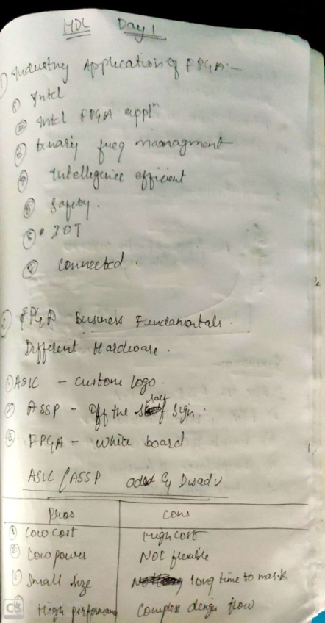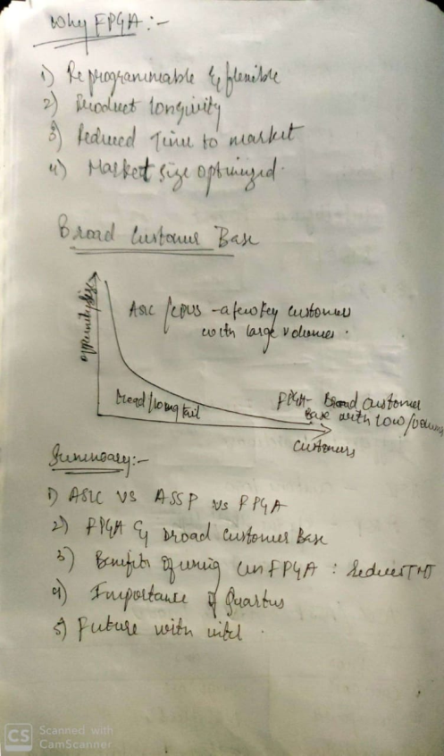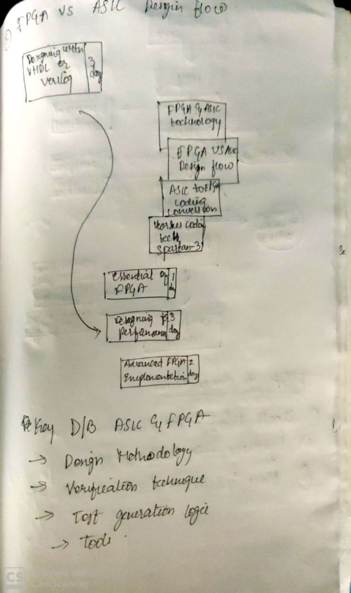

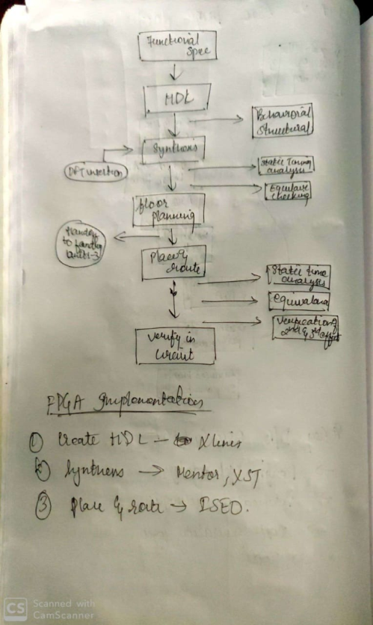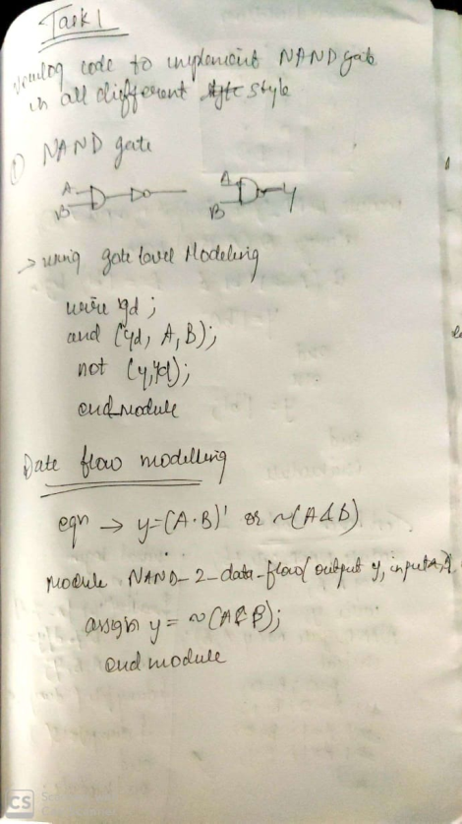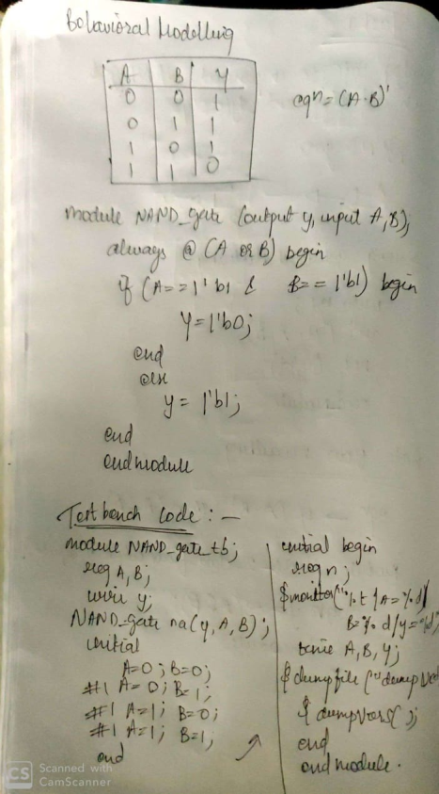

**DAILY ASSESSMENT FORMAT**

|  |  |  |  |  |  |  |  |  |  |  |  |  |  |  |  |  |
| --- | --- | --- | --- | --- | --- | --- | --- | --- | --- | --- | --- | --- | --- | --- | --- | --- |
| |  |  |  |  | | --- | --- | --- | --- | | **Date:** | **1-6-2020** | **Name:** | **Russell D’souza** | | **Course:** | **Python programming** | **USN:** | **4AL15EC023** | | **Topic:** | **1.Build a webcam motion detector** | **Semester & Section:** | **8th A** | | **Github Repository:** | **Russell1005** |  |  | |
|  |
|  |
| **AFTERNOON SESSION DETAILS** | |
| **Image of session** | |

# WebCam Motion Detector in Python

This python program will allow you to detect motion and also store the time interval of the motion.

**Requirement:**

1. Python3
2. OpenCV(libraries)
3. Pandas(libraries)

**Main Logic :** Videos can be treated as stack of pictures called frames. Here I am comparing different frames(pictures) to the first frame which should be static(No movements initially). We compare two images by comparing the intensity value of each pixels. In python we can do it easily as you can see in following code:

filter_none

edit

play_arrow

brightness_4

|  |
| --- |
| # Python program to implement  # Webcam Motion Detector    # importing OpenCV, time and Pandas library  import cv2, time, pandas  # importing datetime class from datetime library  from datetime import datetime    # Assigning our static_back to None  static_back = None    # List when any moving object appear  motion_list = [ None, None ]    # Time of movement  time = []    # Initializing DataFrame, one column is start  # time and other column is end time  df = pandas.DataFrame(columns = ["Start", "End"])    # Capturing video  video = cv2.VideoCapture(0)    # Infinite while loop to treat stack of image as video  while True:      # Reading frame(image) from video      check, frame = video.read()        # Initializing motion = 0(no motion)      motion = 0        # Converting color image to gray_scale image      gray = cv2.cvtColor(frame, cv2.COLOR_BGR2GRAY)        # Converting gray scale image to GaussianBlur      # so that change can be find easily      gray = cv2.GaussianBlur(gray, (21, 21), 0)        # In first iteration we assign the value      # of static_back to our first frame      if static_back is None:          static_back = gray          continue        # Difference between static background      # and current frame(which is GaussianBlur)      diff_frame = cv2.absdiff(static_back, gray)        # If change in between static background and      # current frame is greater than 30 it will show white color(255)      thresh_frame = cv2.threshold(diff_frame, 30, 255, cv2.THRESH_BINARY)[1]      thresh_frame = cv2.dilate(thresh_frame, None, iterations = 2)        # Finding contour of moving object      cnts,_ = cv2.findContours(thresh_frame.copy(),                         cv2.RETR_EXTERNAL, cv2.CHAIN_APPROX_SIMPLE)        for contour in cnts:          if cv2.contourArea(contour) < 10000:              continue          motion = 1            (x, y, w, h) = cv2.boundingRect(contour)          # making green rectangle arround the moving object          cv2.rectangle(frame, (x, y), (x + w, y + h), (0, 255, 0), 3)        # Appending status of motion      motion_list.append(motion)        motion_list = motion_list[-2:]        # Appending Start time of motion      if motion_list[-1] == 1 and motion_list[-2] == 0:          time.append(datetime.now())        # Appending End time of motion      if motion_list[-1] == 0 and motion_list[-2] == 1:          time.append(datetime.now())        # Displaying image in gray_scale      cv2.imshow("Gray Frame", gray)        # Displaying the difference in currentframe to      # the staticframe(very first_frame)      cv2.imshow("Difference Frame", diff_frame)        # Displaying the black and white image in which if      # intensity difference greater than 30 it will appear white      cv2.imshow("Threshold Frame", thresh_frame)        # Displaying color frame with contour of motion of object      cv2.imshow("Color Frame", frame)        key = cv2.waitKey(1)      # if q entered whole process will stop      if key == ord('q'):          # if something is movingthen it append the end time of movement          if motion == 1:              time.append(datetime.now())          break    # Appending time of motion in DataFrame  for i in range(0, len(time), 2):      df = df.append({"Start":time[i], "End":time[i + 1]}, ignore_index = True)    # Creating a CSV file in which time of movements will be saved  df.to_csv("Time_of_movements.csv")    video.release()    # Destroying all the windows  cv2.destroyAllWindows() |

**Analysis of all windows**  
After running the code there 4 new window will appear on screen. Let’s analyse it one by one:

1. **Gray Frame :**In Gray frame the image is a bit blur and in grayscale we did so because, In gray pictures there is only one intensity value whereas in RGB(Red, Green and Blue) image thre are three intensity values. So it would be easy to calculate the intensity difference in grayscale.
2. **Difference Frame :** Difference frame shows the difference of intensities of first frame to the current frame.  
   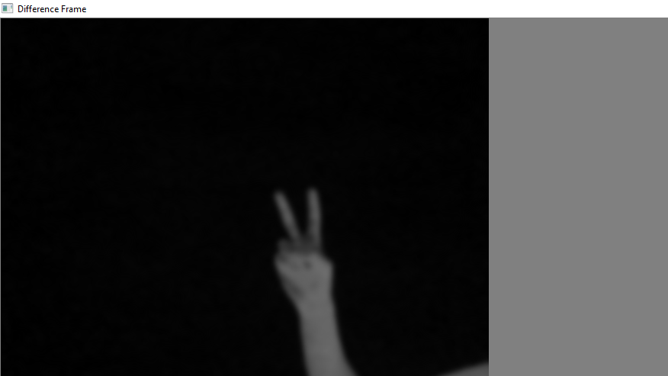
3. **Threshold Frame :**If the intensity difference for a particular pixel is more than 30(in my case) then that pixel will be white and if the difference is less than 30 that pixel will be black  
   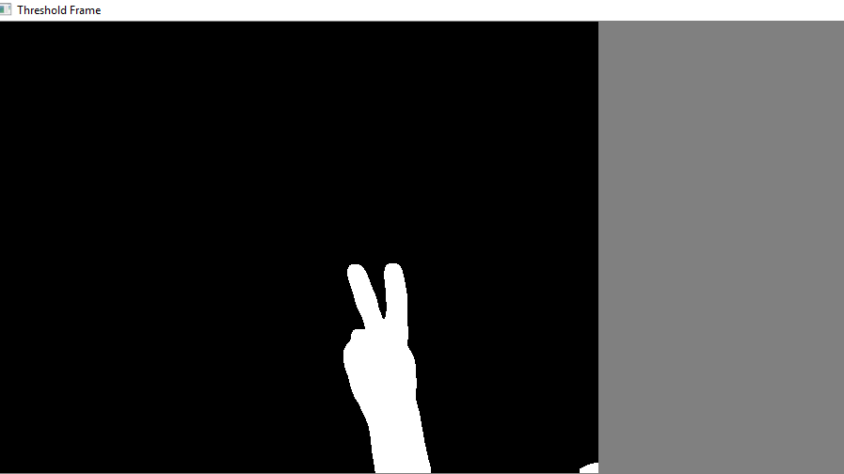
4. **Color Frame :**In this frame you can see the color images in color frame along with green contour around the moving objects  
   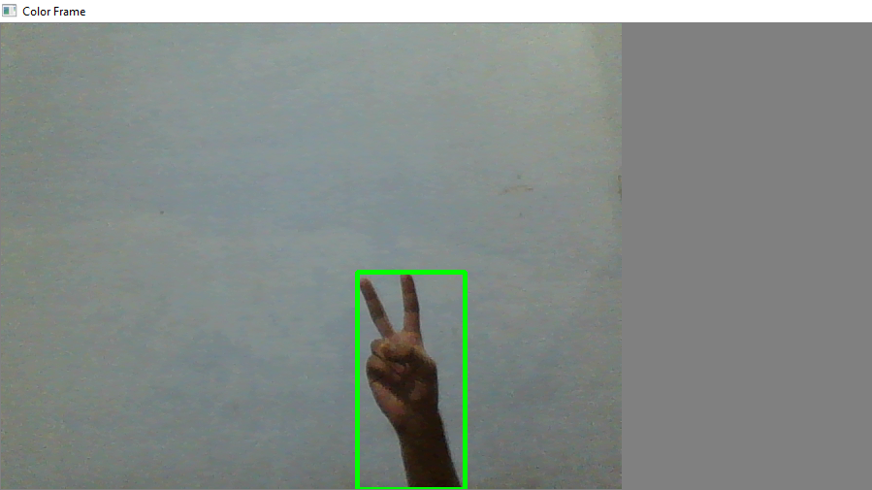

**Time Record of movements**

The Time_of_movements file will be stored in the folder where your code file is stored. This file will be in csv extension. In this file the start time of motion and the end time of motion will be recorded. As you can see in picture:  
